The Poisson Probability Distribution
  - Paraphrased by me
Beginning with a definition, a discrete random variable X is said to have a Poisson distribution with parameter (mu) µ (where µ > 0) if the pmf (probability mass function) of X is:
p(x; µ) = ( e^{-µ} * µ^{x}) / (x!), or
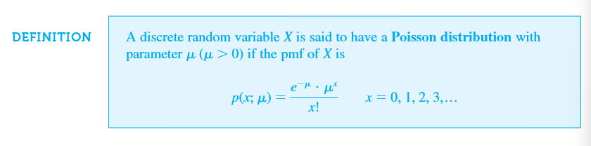
Keeping in mind that µ is the expected value of X, and e represents Euler’s number, or 2.71828.
Using an example, we’ll let the discrete random variable X represent the number of traps in a particular type of transistor and that is has a Poisson distribution with µ (mu) = 2.
The probability that there are exactly 3 traps, is:
P(X = 3) = p(3;2) = (e⁻²2³) / (3!) = .180,

And to calculate the probability that there are at most three traps, we use
P(X ≤ 3) = F(3;2) = ∑ (starting at x = 0, to x = 3)
(e⁻²2^{x}) / (x!) = .135 + .271 + .271 + .180 = .857
To summarize this process, it’s a simple manner of plugging in the given values to their corresponding places in the equation. Given that we are provided the discrete (countable), random variable value, X (or the desired range of values), and µ (mu, which represents the value of a Poisson distribution parameter), we can calculate the probability that there are X number of events (in this case, traps) occurring in a fixed interval of time or space.
To spell out the equation, we’re dividing the product of e to the power of negative mu and mu to the power of x by x factorial. A simple way to remember this is to start with the factorial of x in the denominator, place mu in its proper position, and to lastly place the e and x variables where they belong. Process of elimination is the best way to go about this.

